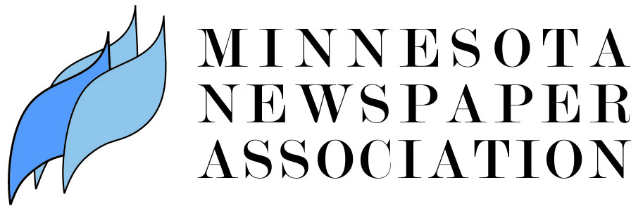

RELEASE FOR MINNESOTA NEWSPAPER WEEK
AUGUST 13-19, 2017

Contact: Lisa Hills, Executive Director
Email: lisa@mna.org
Phone: 612-278-0222

Minneapolis (August 13, 2017) -- This week, more than 200 newspapers across the State of Minnesota will publish no news on their front pages. This “Whiteout” is taking place during Minnesota Newspaper Week, August 13-19, a part of the Minnesota Newspaper Association’s yearlong celebration of its 150th Anniversary. The Whiteout reminds Minnesotans of the important role that newspapers play, writing the first draft of history and telling the stories of their communities.

“In many communities across the State of Minnesota, the newspaper is the main source of local news,” said MNA Executive Director Lisa Hills. “Newspaper journalists across the state attend city council and school board meetings, they cover town festivals and local sports teams, and they arrive on the scene to document history during natural disasters and other community challenges. We know newspapers play an important role.”

Today, 25 daily and 295 non-daily newspapers, from Worthington to Warroad, Bird Island to Baudette, Elbow Lake to Ely and every community in between, belong to the Minnesota Newspaper Association.

“Minnesota Newspaper Week is a statewide initiative that reminds individuals of the importance of a free press,” reads Governor Mark Dayton’s proclamation. “Freedom of the Press promotes a well-informed constituency, improves public policy, increases responsiveness and accountability, and enhances public confidence in governmental institutions.”

Minnesotans agree that newspapers play a vital role in the state. MNA’s member newspapers have a total circulation of more than 2.2 million each week. A 2014 Scarborough readership survey found that 89 percent of Minnesotans accessed a newspaper in print and/or digital format in the past month. Minnesotans of all ages read Minnesota newspapers in print and online. It’s no wonder that in a state where many read their local newspaper, the population is also civic-minded and involved in activities like voting in local elections. According to state officials, more than 81 percent of registered Minnesota voters cast ballots in the November 2016 election. That’s just under 75 percent of eligible Minnesotans.

“We are proud to support Minnesota’s vibrant newspaper industry and look forward to being here for the next 150 years,” said Hills.
# # #

About the Minnesota Newspaper Association

The Minnesota Newspaper Association (MNA) is the voluntary trade association of all general-interest newspapers in the State of Minnesota, acting on behalf of the newspaper press of the state, representing its members in the legislature and in court, managing local/regional/national newspaper advertising placement, operating a press release service, and working to enhance the quality of the state’s newspapers.

